NST21022 - Practical for Network Switching and Routing
Department of Information and Communication Technology
Faculty of Technology
Labsheet :9
Reg. Number: SEU/IS/20/ICT/084
Academic Year :2020/2021
Practical No :9

Title: Introduction to Network Traffic
Aim:
• Getting familiar with OSI and TCP/IP models

Task:
• Investigate OSI and TCP/IP models with Packet Tracer Simulation mode

Use “NST21022 Lab sheet 09.pkt” file
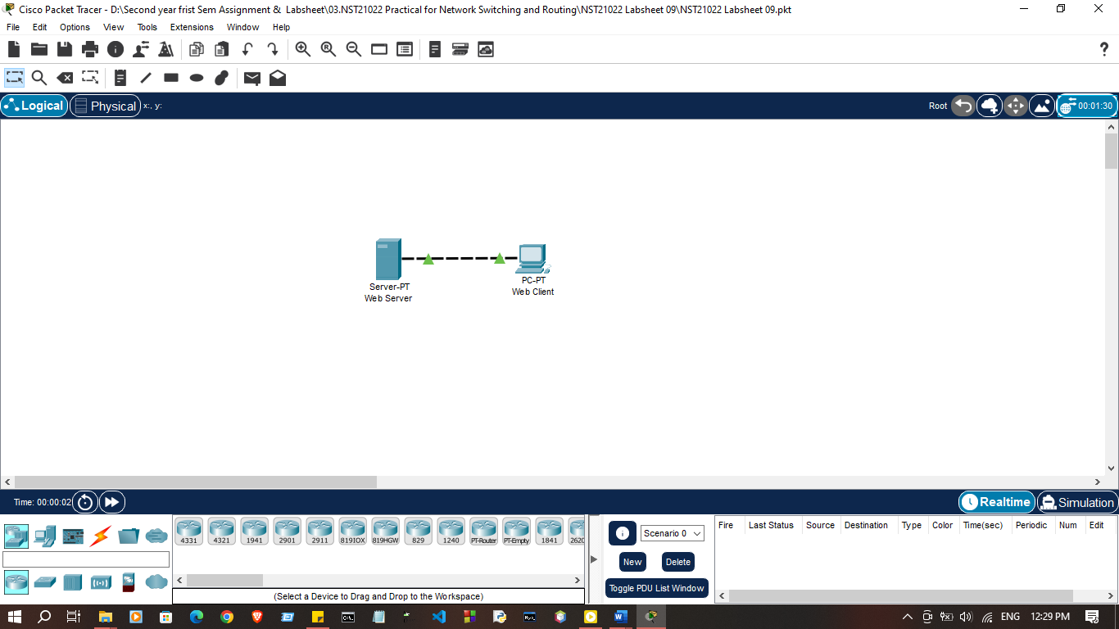
Activities

- Open packet tracer file name “NST21022 lab sheet 09.pkt” and Click the Simulation mode icon to switch from Realtime mode to Simulation mode.
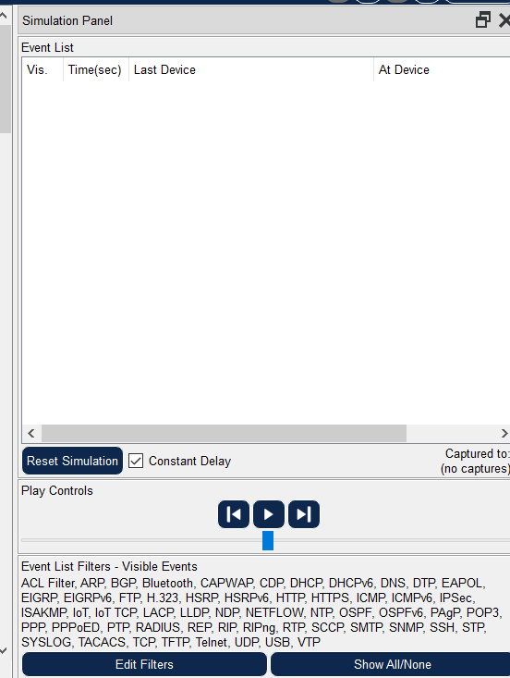
- Select HTTP from the Event List Filters.
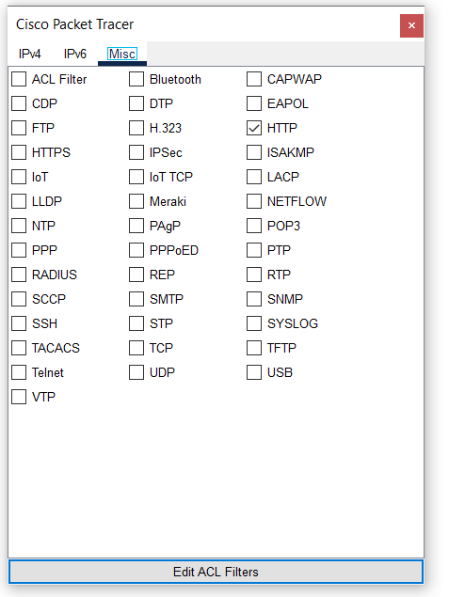
- Click Web Client in the far left pane.
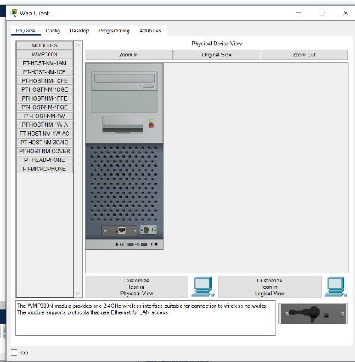
- Click the Desktop tab and click the Web Browser icon to open it.
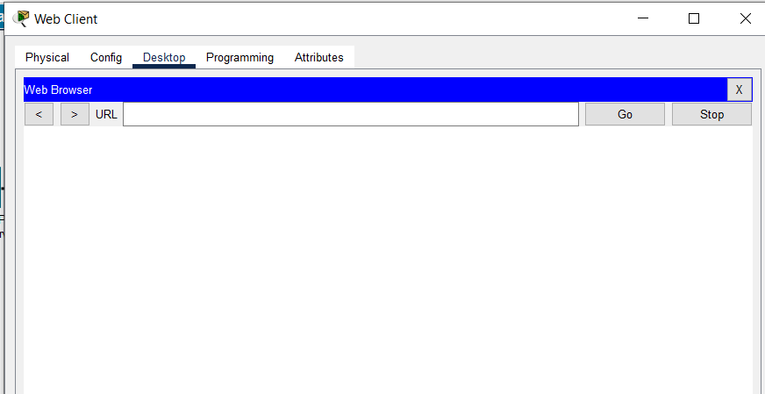
- In the URL field, enter www.server.com and click Go.
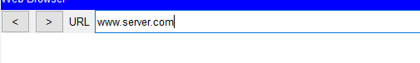
- Click Capture/Forward four times. There should be four events in the Event List
  - Look at the Web Client web browser page. Did anything change? And what?
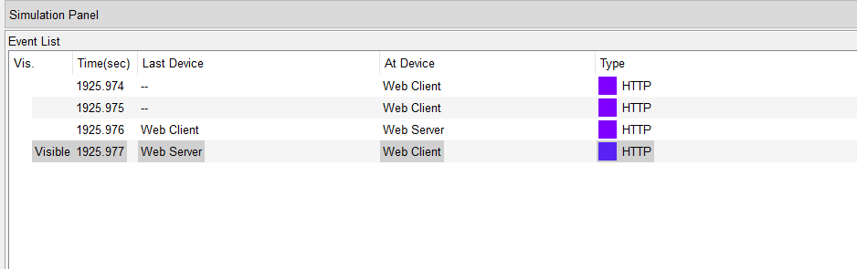
- Click the first colored square box under the Event List > Type column. It may be necessary to expand the Simulation Panel or use the scrollbar directly below the Event List.
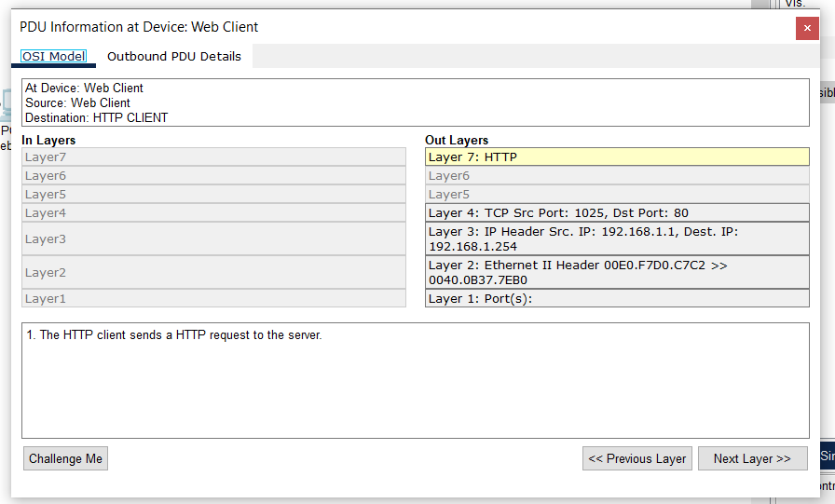
- Ensure that the OSI Model tab is selected.
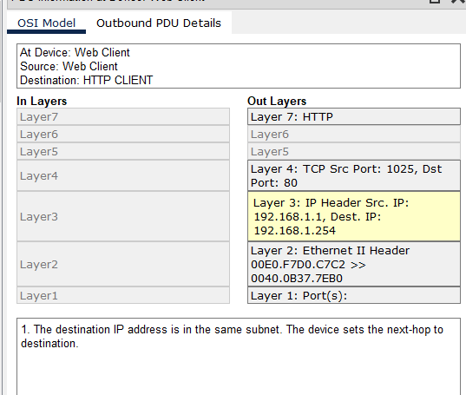
  - What information is listed in the numbered steps directly below the In Layers and Out Layers boxes for Layer 7?
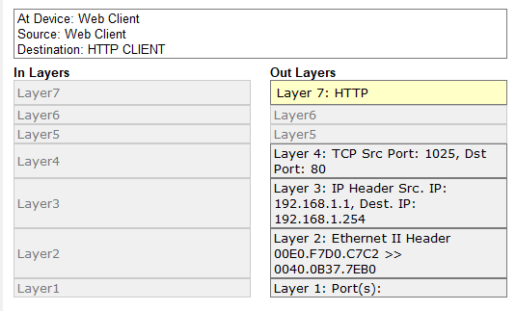
  - What is the Dst Port value for Layer 4 under the Out Layers column?
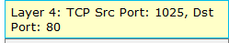
  - What is the Dst IP value for Layer 3 under the Out Layers column?
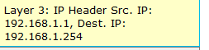
  - What information is displayed at Layer 2 under the Out Layers column?
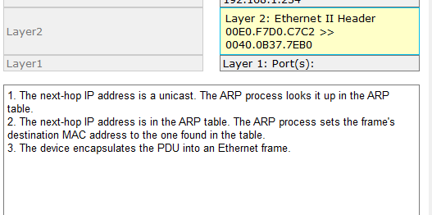
- Click the Outbound PDU Details tab. Information listed under the PDU Formats is reflective of the layers within the TCP/IP model.
  - What is the common information listed under the IP section of PDU Details as compared to the information listed under the OSI Model tab? With which layer is it associated?
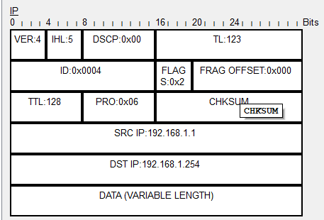
  - What is the common information listed under the TCP section of PDU Details, as compared to the information listed under the OSI Model tab, and with which layer is it associated?
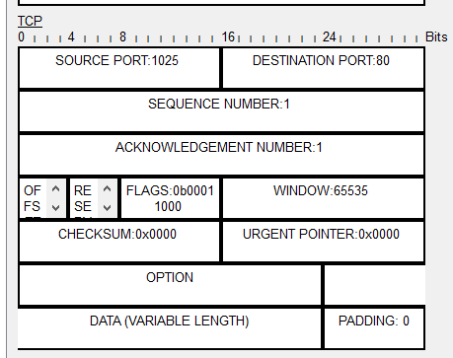
- Click the next colored square box under the Event List > Type column. Only Layer 1 is active (not grayed out). The device is moving the frame from the buffer and placing it on to the network.
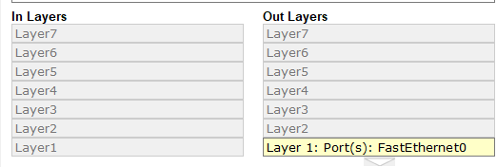
- Advance to the next HTTP Type box within the Event List and click the colored square box. This window contains both In Layers and Out Layers. Notice the direction of the arrow directly under the In Layers column; it is pointing upward, indicating the direction the data is travelling. Scroll through these layers making note of the items previously viewed. At the top of the column the arrow points to the right. This denotes that the server is now sending the information back to the client.
  - Comparing the information displayed in the In Layers column with that of the Out Layers column, what are the major differences?
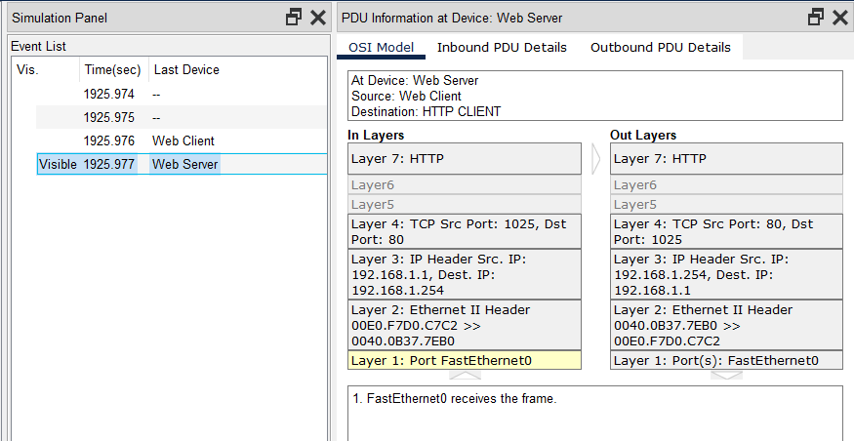

- Click the Inbound and Outbound PDU Details tab. Review the PDU details.
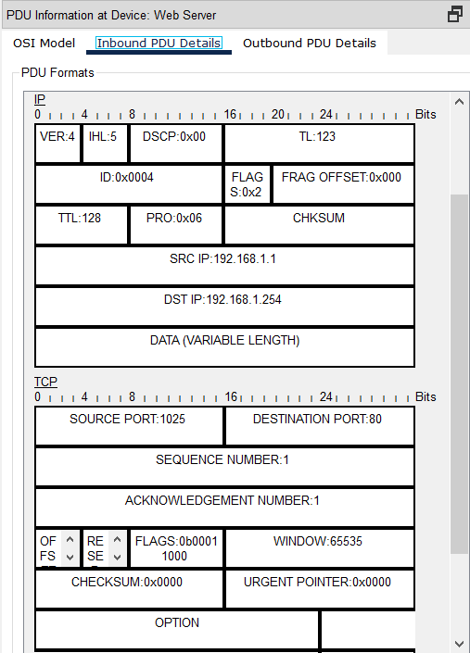
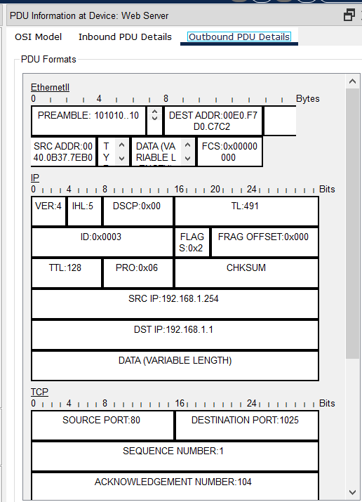
- Click the last colored square box under the Info column.
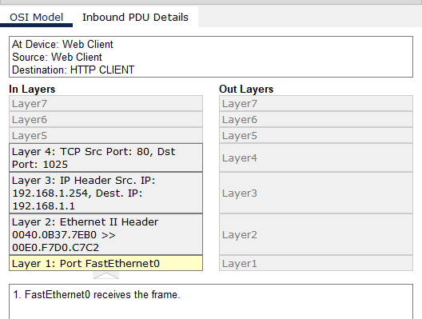
- Close any open PDU information windows.
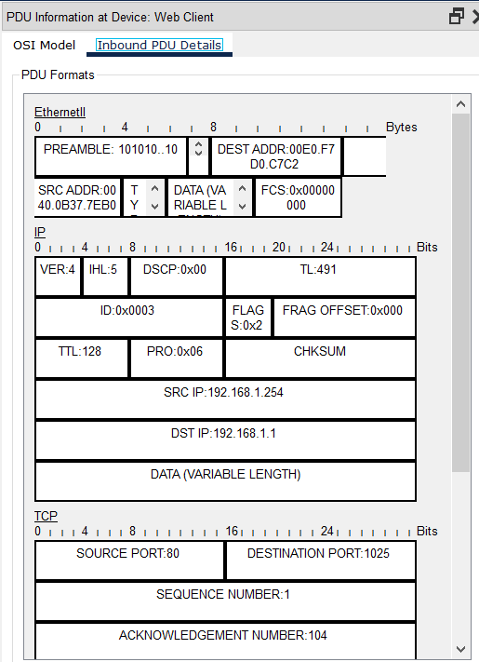

- In the Event List Filters > Visible Events section, click Show All/None.
  - What additional Event Types are displayed?
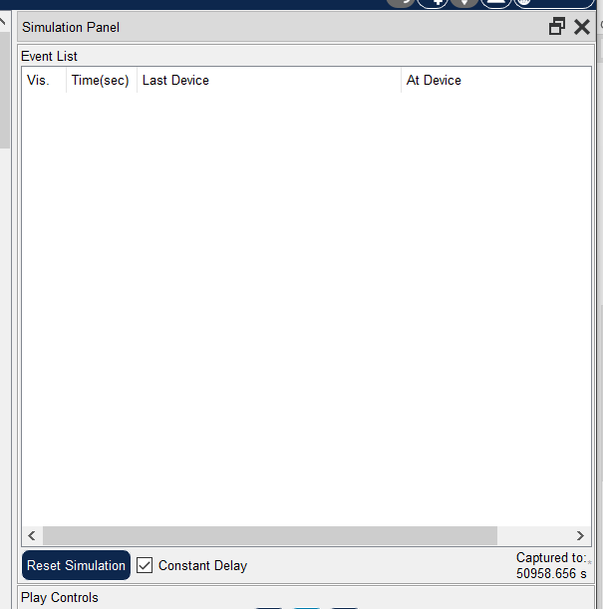

- Click the first DNS event in the Type column. Explore the OSI Model and PDU Detail tabs and note the encapsulation process. As you look at the OSI Model tab with Layer 7 highlighted, a description of what is occurring is listed directly below the In Layers and Out Layers (“1. The DNS client sends a DNS query to the DNS server.”). This is very useful information to help understand what is occurring during the communication process.
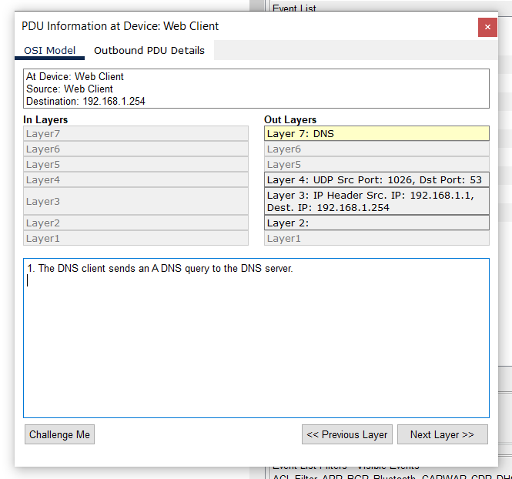
- Click the Outbound PDU Details tab.
  - What information is listed in the NAME field: in the DNS QUERY section?
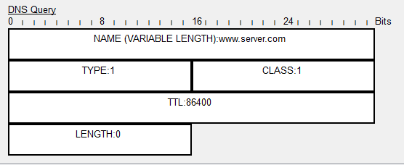
- Click the last DNS Info colored square box in the event list.
  - At which device was the PDU captured?
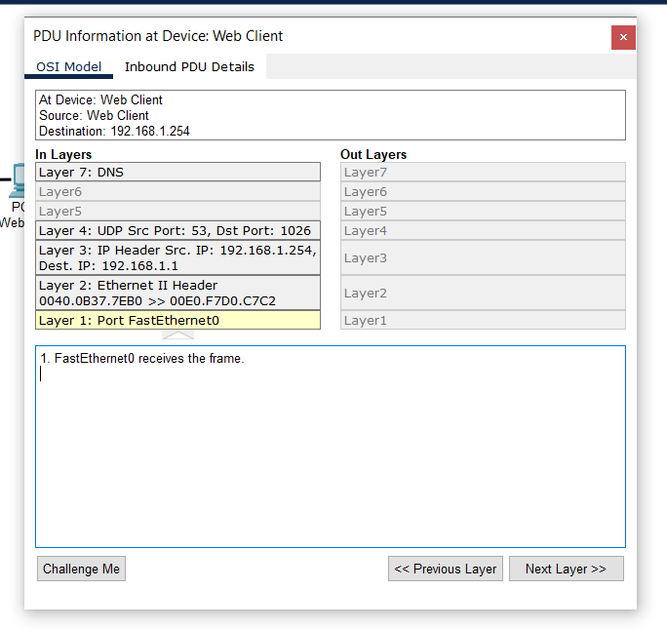
  - What is the value listed next to ADDRESS: in the DNS ANSWER section of the Inbound PDU Details?
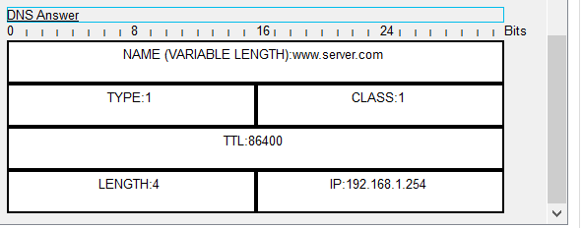
19.Find the first HTTP event in the list and click the colored square box of the TCP event immediately following this event. Highlight Layer 4 in the OSI Model tab.
a.In the numbered list directly below the In Layers and Out Layers, what is the information displayed under items 4 and 5?
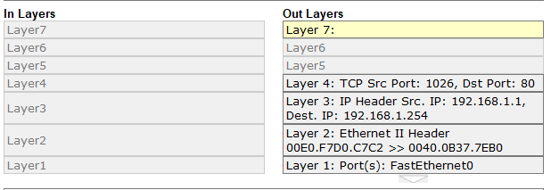
20.Click the last TCP event. Highlight Layer 4 in the OSI Model tab. Examine the steps listed directly below In Layers and Out Layers.
b.What is the purpose of this event, based on the information provided in the last item in the list (should be item 4)?

Discussion

- In this lab session, we explored the OSI and TCP/IP models using Packet Tracer's Simulation mode to understand how data flows through a network. By investigating these models, we gained insights into the different layers involved in network communication, such as how the OSI model's seven layers correspond to specific functions, and how the TCP/IP model streamlines these functions into four layers. Through Packet Tracer's simulation, we observed how data packets move from one device to another, passing through each layer of the models. This practical investigation helped solidify our understanding of the OSI and TCP/IP models' roles in network communication and data transmission.

